# Project Design Phase-I Solution Architecture

|  |  |
| --- | --- |
| Date | 8 october 2022 |
| Team ID | PNT2022TMID14050 |
| Project Name | Smartframer IOT-Enabled Smart Framing Application |
| Maximum Marks | 4 Marks |

**Solution Architecture:**

The current global needs of humanity, new solutions and technologies are constantly being proposed and implemented:

* IoT is defined as the network of all objects that are embedded within devices, sensors, machines, software and people through the Internet environment to communicate, exchange information and interact in order to provide a comprehensive solution between the real world and the virtual world.
* security technologies need to be continuously improved, but in our opinion, the application of IoT solutions for smart agriculture is inevitable and will enhance productivity, provide clean and green foods, support food traceability, reduce human labour, and improve production efficiency

# IoT application for monitoring farming conditions in a greenhouse Architecture:

*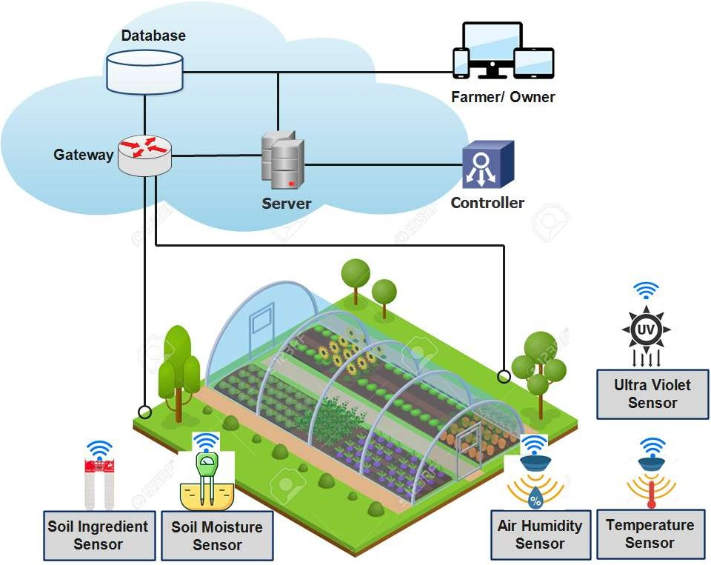jjk*

**PERFORMANCE:**

* It requires an unlimited or continuous internet connection to be successful.
* It should be rural communities, especially in the developing countries where we have mass crop production, it is completely impossible to operate this farming method.

**RELIABILITY:**

* Poor Internet Connectivity in Farms. Most farms are located in remote locations where internet connectivity might not be strong enough to facilitate fast transmission speeds. ...
* High Hardware Costs. ...
* Disrupted Connectivity to the Cloud.

**USABILITY:**

 The new technologies which have arisen at the dawn of the Fourth Industrial Revolution in the areas of agriculture and cattle production to increase production quantity and quality, by making maximum use of resources and minimising the environmental impact.